**Nigeria COVID-19 Data Analysis**

This is the analysis of the Coronavirus disease (COVID-19) in Nigeria. COVID-19 has affected many major parts of the world, Nigeria inclusive. Nigeria is a West African country with 37 states including Federal Capital Territory. COVID-19 has affected several activities in the country. Python was used in this analysis to collect data, perform analysis and create visualization.

The datasets used for this analysis are

-NCDC COVID-19 data across all the 37 states in Nigeria.

-John Hopkins daily data on confirmed, death and recovered cases.

-Vulnerability index data for the 37 states in Nigeria.

-GDP data for each quarter of the year from year 2014 to 2020 in Nigeria.

-Budget data for each state in Nigeria.

I used different Pandas method, matplotlib and seaborn visualization plots to explore and analyze the data.

The insights are as follows:

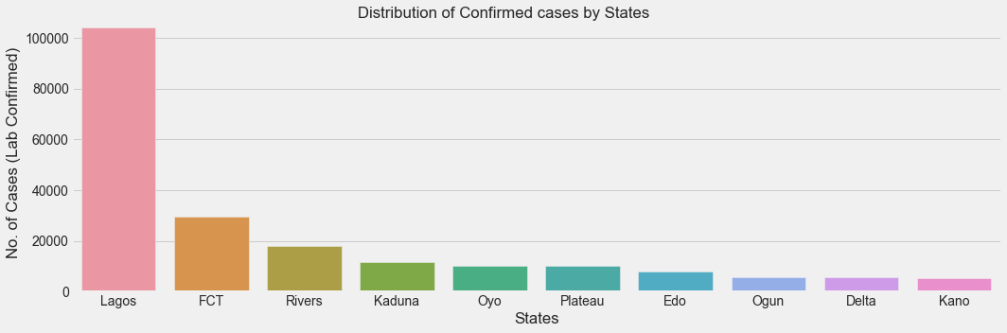

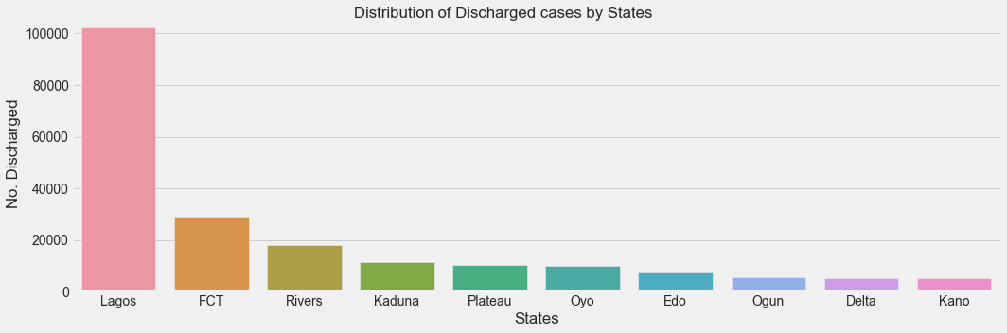

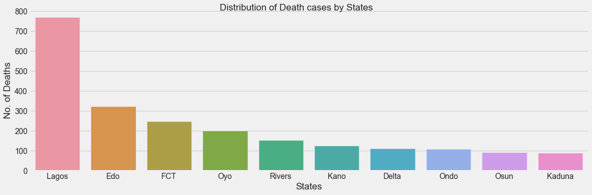

* Lagos state recorded the highest number of confirmed, discharged and death cases in Nigeria.

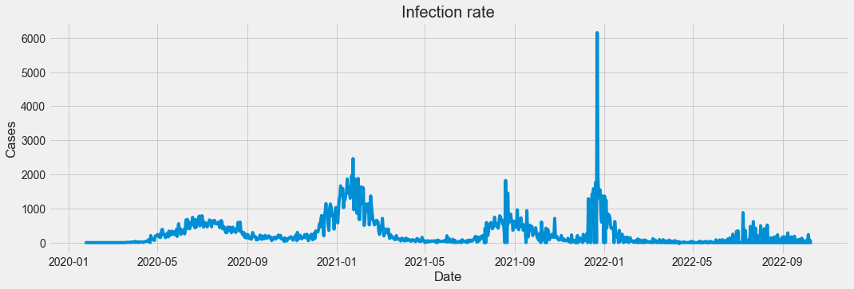

* The highest number of daily new cases (6158 cases) was recorded towards the end of year 2021 (22nd of December, 2021).
* The infection rate was lowest around the middle of the years 2021 and 2022.

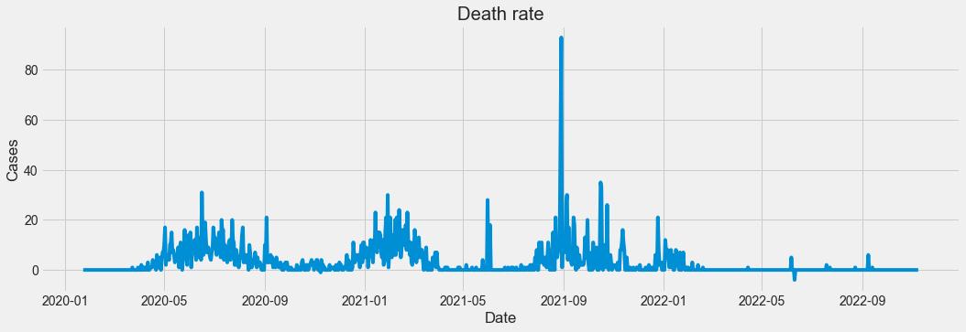

* The highest number of daily death cases (93 cases) was recorded on the 29th of August, 2021.

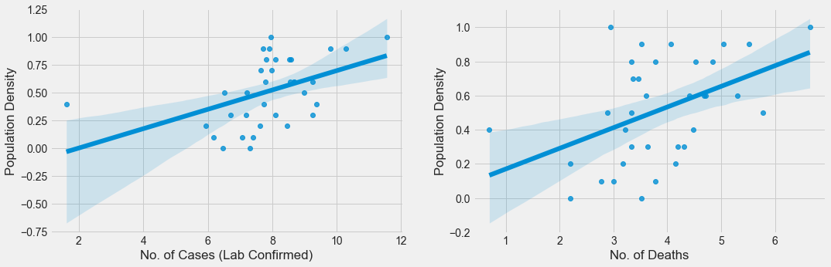

* An increase in the population density influences an increase in the number of confirmed cases and deaths.

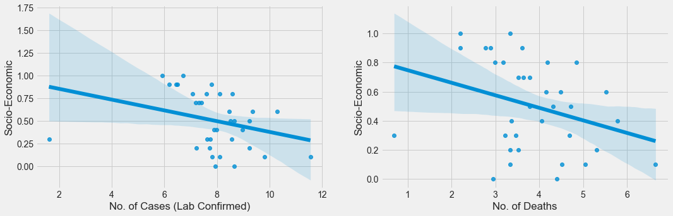

* A decrease in the socio-economic index influences an increase in the number of confirmed cases and deaths.

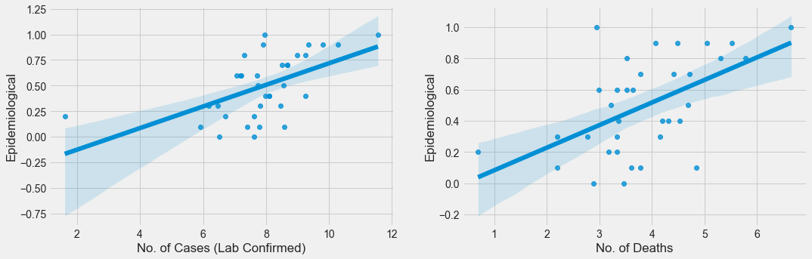

* The higher the Epidemiological index, the higher the number of confirmed cases and deaths.

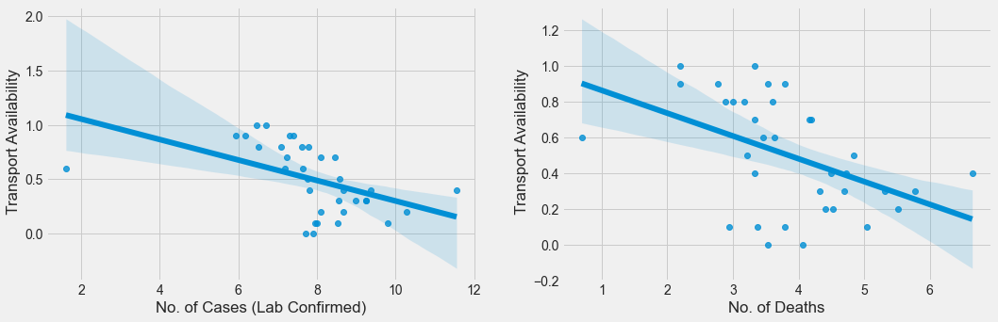

* A decrease in transport availability influences an increase in the number of confirmed cases and deaths.

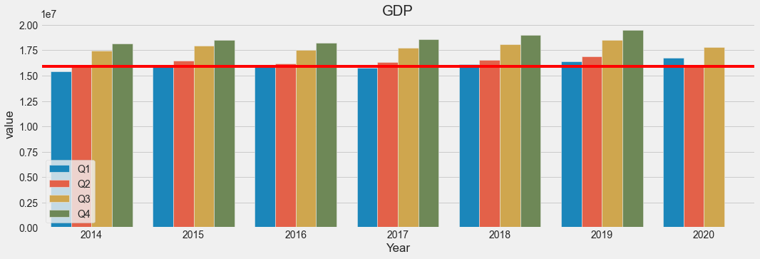

* The GDP increases towards the last quarter for each year from 2014 to 2019.
* The highest GDP was recorded in the fourth quarter of 2019.
* There was a decrease in the GDP in the second quarter from the first quarter in year 2020.

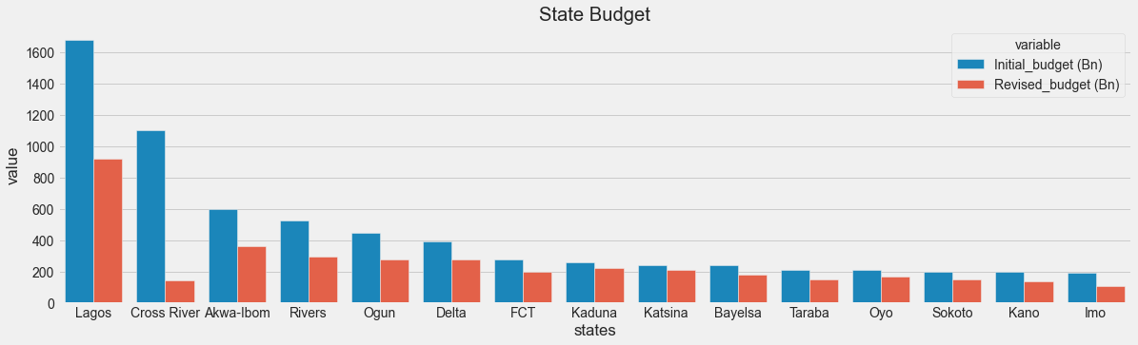

* Cross River state budget was the most affected by the COVID-19 with a budget reduction of about 950 billion.
* Lagos state budget was also greatly affected by COVID-19 with a budget reduction of about 650 billion.